e
•O
-
"'
i
-.¡.;;
.e ,
o
e

E
]
.,
..
-o
-o
..
-o
-¡;:
""
.e.
i.,
-o.,
[L"'
Memorandum of Understanding

THE FUNDACIÓN GALILEO GALILEI - INAF (FGG)

ANO

THE INSTITUTO DE ASTROFÍSICA DE CANARIAS (IAC) ON THE HOUSl'NG WORKS FOR THE STRIP TELESCOPE
AT THE TEIDE OBSERVATORY

REVISED VERSION 31·10-2023 1/7

ÁMBITO- PREFIJO | csv | FECHA Y HORA DEL DOCUMENTO
GEISER | GEISER-7d17-ca09-a194.-5ba7-4cf8-0997-c3ed-6c3a | 10/11/2023 14:03:09 Horario iinsular
Nº registro | DIRECCIÓN DE VALIDACIÓN | Validez del documento
REGAGE23e000764!33580 | https://sed!e.administracionespublicas.gob.es/valida | Original

THE PARTIES

Professor Rafael Rebolo López, in his capacity as Director of the Consorcio Instituto de Astrofísica de Canarias (hereinafter, IAC), Calle Vía Láctea, s / n, 38201 San Cristóbal de La Laguna, Santa Cruz de Tenerlfe, Spain and CIF Q3811001A, actlng on its behalf by virtue of the appointment made by the Governing Board of the IAC on August 2, 2013, and with the powers conferred on him in accordance wlth the Law 14/2011 of June 1st, on Scienc,e, Technology and Innovation, and in the Statutes of the IAC (BOE o'f December 21, 2018),

AND,

Dr. Adriano Ghedina, ln his capac:ity as Director of the Fundación Galileo Galilei - INAF Fundación Canaria, (hereafter, FGG-INAF), based in Rambla José A. Fernández P. , 7, 38712 San Antonio de B. Baja, Santa Cruz de Tenerife:, Spain, acting on its behalf by virtue of the appointment made by the Patronato de la Fundaci6n Galíleo Ga/llei, on November 3rd, 2022 and with the powers conferred on him in accordance with the current FGG-INAF Statute.

The IAC ancl FGG-INAF shall be referred to jolnt:ly as the "Partles" and individually as a "Patty". The Parties recognize their legal capacity to enter into this MoU on behalf of their institutions, and

MANIFEST

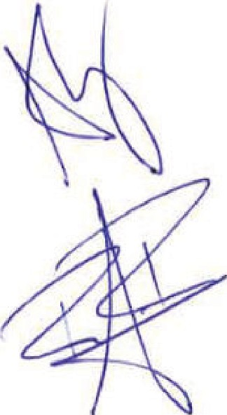
- That the Spanish State Administration has exch.isive competence for the promotion and general coordination of scientific and technical research in Spain, in accordance with the Spanish Constltution of December 29, 1978, in article 149.1.15ª.

- That the IAC is a Spanish l?ublic Research Organization, lega:Uy constilt1led as a Public Consortium and integrated by the General Administration 1of the State, the Publlc Administration of lfle Autonomous Community of the Canary lslands, the Un1iversity of La Laguna and the Superior Council of Scientific Research (CSIC), in accordance with the Law 14 f 2011 of June 1, of Science, Technology and lnnovation.

- That the purposes of the IAC, in accordance· with its Statutes (Official State Gazette, December 21, 2018), are astrophysical research, the development of scientific iinstrumentation, the train1ing of research personnel, the administration of tihe Canary lslands Observatories (hereafter, "Observatorios de Canarias1
')
- and scienMic outreach.
"'

REVISED VERSION 31·10·2023 2/7

ÁMBITO- PREFIJO | csv | FECHA Y HORA DEL DOCUMENTO
GEISER | GEISER-7d17-ca09-a194.-5ba7-4cf8-0997-c3ed-6c3a | 10/11/2023 14:03:09 Horario iinsular
Nº registro | DIRECCIÓN DE VALIDACIÓN | Validez del documento
REGAGE23e000764!33580 | https:l/sed!e.administracionespublicas.gob.es/valida | Original

- That the FGG-INAf is a Spanish non-profit institution. The FGG's aim is to promote:
  - astrophysical research by managing the Telescopio Nazionale Galileo (TNG), located in the lsland of San Míguel de La Palma, together with other scientiñc, technical and administrative facilities, and;
  - also any o her astrophysical activily that INAF wants to develop.
- Thal pr1ior to FGG-llNAF's constitutíon ltaly signed on 2 July 1992 tile Protocol on Cooperation in Astrophysical research in Spain.

- That the FGG-INAF, which is acting on behalfof INAF, and the IAC have mutual interest in the ínstallation and operatio,nof the STRliP telescope at the Teide Observatory;

- The STRIP microwave t:elescope is beíng developed within the Large Scale Polarization Experiment (LSPE) program, funded by an international consortium of which INAf and IAC are members. LSPE objective is the high precision measurement: of the cosmic microwave background polarizatiion, with the aim of searching the presenoe of gravitational waves at the time of cosmic intlation (t
-10·35 s, E-1035GeV). LSPE is composed of 2 instruments: SWIPE in a
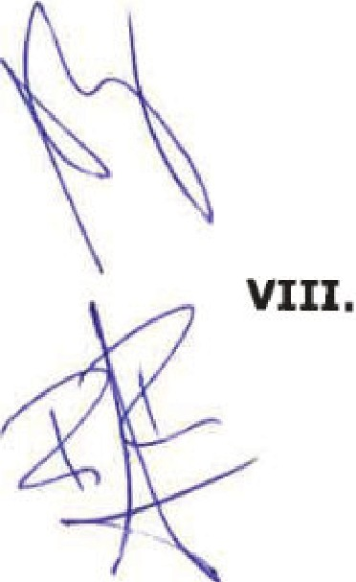
stratospherlc balloon will measure in, the frequency bands of 140. 220 and 240 Hz, while STRIP will be iinsta11ed at the T1eide Observatory in Tenerife and will obse1ve in two bands at 40 and 90 Hz. The Teide Observatory is chosen dueto the low content of water vapour in t!ie atmosphere and the presence of already installed complementary instrumentation as QU'IJOTE and GroundBIRD. In order to install the STRIP telescope at the site lhosted by !he Observatorio del Teide, it is neoessary lo reform the agreed housing of the telescope and complete t:he instalfation with roof, concrete platforms, power and data lines.

That as the Kingdom of Spain opened the Observatorios de Canarias to the internalional scientific 1community by means of lhe 1nternational Treaty: "Agreement on Co-operalion in Astrophysics and its Protocol", which was signed on 26 May 1979, and ltaly adhered to the Treaty in 1992, the proposed STRIP experiment is invitad by IAC to be installed at the Teide Observatory i1n accordance wiith !he terms and conditions hereby established.

IX. The FGG-INAF and the IAC have established this MoU, as expressed in Clauses 1 to 4, and Appendices A B C (which are integral part of this MoU), in accordance with the following:

o
"' REV[SED VERSIONI 31-10-2023 3/7

ÁMBITO· PREFIJO GEISER
Nº registro
csv
GEISER-7d17-ca09-a194-5ba7-4cf8-0997-c3ed-6c3a DIRECCIÓN DE VALIDACIÓN
FECHA Y HORA DEL DOCUMENTO
10/11/2023 14:03:09 Horario iinsular Validez del documento
REGAGE23e000764!33580 https://sed!e.administracionespublicas.gob.es/valida Original

llllllllllllllllllllllllllll llllllllllllllllllllllllllllllllllllllllllllllllllllllllllllllll l llllllllllllllllllllllllllllllllllllllllllll llll llllll

CLAUSES

- OBJECT OF THE MoU

The purpose of this MoU is set the collaborative framework of FGG-INAF and !he IAC for the installation of the STRIP telescope at ttie Teide Observatory,, Tenerife, under the lerms and conditions contemplated he.reafter.

- THE PARTIES HEREBY AGREE

  - In arder to reirnforce the participation of INAF in the STRllP pr,oject. the FGG INAF, acting on beha,'lfof the INAF, is willing to transfer to the IAC funds up to a maximum of 65 keuro to contribute to the reform and conditioning works of the housing for the STRIP telescope at Teide Observatro. Any transfer of funds will be made via proper invoicing by IAC.
  - The IAC will be respons1ible 1o pu1blish any tender for the works, assign the works to the selected construction company and of presenting all required documents to obtain local construction licences;
  - The IAC shall be responsible of the supervisio11 and safety on site of the reform works;
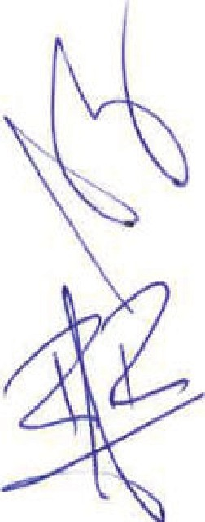
  - The FGG-llNAF will have no rights nor responsibiliUes on the works done for the housing;
  - The FGG-INAF will nave no responsabilities nor charges far extra expenses that will derive from the construction works;
2:.6 The IAC shall issue a reoeipt documenl of the quantity received as well as a certificate at the ending of the reform works.

- DURATION Of THE MoU

  - This MoU will be eHective once it has been signed by the representativas of the

Panies.
  - This MoU will have an initial duration of 2 years, and may be renewed for additional periods by mutual agreement in writing between the al.llhorized repres.entatives of the parties while ltaly is adhering to the lntematicmal Treaty and it has not been cancelled by Spain.

- TERMINATION OR RESOLUTION OF THE MoU

  - This MoU will terminate when the objeclives have been achieved or in the event of its cancellation.
  - The following are the causes of termination:
- 4.2.a) Completion of the period of its validity without an agreement to extend it.
"'
    - The 1.manimous agreement of the sígnatories.

REVISED VERSION 31-10-2023 4/7

ÁMBITO- PREFIJO csv FECHA Y HORA DEL DOCUMENTO
GEISER GEISER-7d17-ca09-a194.-5ba7-4cf8-0997-c3ed-6c3a 10/11/2023 14:03:09 Horario iinsular
Nº registro DIRECCIÓN DE VALIDACIÓN Validez del documento
REGAGE23e000764!33580 https:l/sed!e.administracionespublicas.gob.es/valida Original

llllllllllllllllllllllllllll llllllllllllllllllllllllllllllllllllllllllllllllllllllllllllllll l llllllllllllllllllllllllllllllllllllllllllll llllllllll
    - Failure to cornply with the obligations and commitments assumed by one of the signatories.
In this case, any of the parties may notify the non-periorming party of a requirement to comply in a certain period with the obligatio:ns or commitments that are considered unfulfilled. This requiremen1 shall be communicated to the person in eharge of the mechanism for monitoring, enforcing and controlling the execution of the MoU and to !he other signatory parties.
lf after the period specified in the request the breach persists, the party who addressed it wm notify the signing parties of the
concurrence of the cause of resolulion and the MoU will be deemed resolved.
    - By judicial decision declaring the MoU to be null and void.
    - Dueto force majeure or failure to comply with the proposed object. such as not having sufficient funding to participate. In this case, formal notification must be provided to the other party at least six months in advance.
    - For any other cause difl'erent from the previous ones that is foreseen in law.

APPENDICES ATTACHED ARE:

APPENDIX A - TECHNICAL DESCRIPTION OF THE STRIP TELESCOPE APPENDIX B - OBSERVATION SITE OF THE STRIP TELESCOPE

For the FUNDACIÓN GAULEO

GALILEI - INAF
For the INSTITUTO DE

ASTROFÍSICA DE CANARIAS

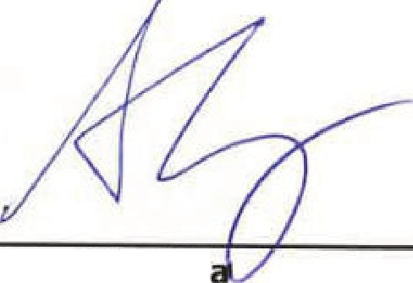
Director

Dr. Adriano Ghedin
Date: 'bl /(íl
/wd
Prof. Rafael Reboto lópe·z

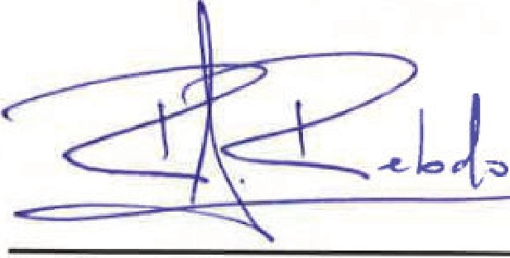
Director
Date: 3 \ J \ 1 L_t> -z3.

o
"' RE:VISED VERSION 31-10-2023 5/7

APPENDIXA

DESCRIPTION O:F THE STRIP EXPERIMENT

The STRIP experiment will comprise:

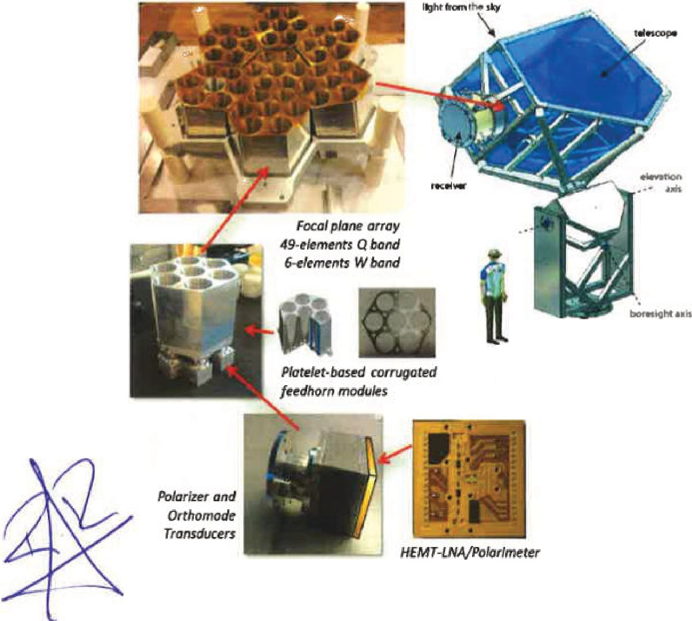
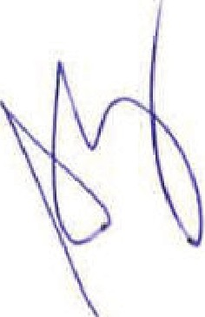
A 1.5m-aperture dauble-refiectar, off-axis telescope mour1ted on a ratating structure. The telescope and instrument will be located in one of the three former enclosures of the VSA.
..iiftl_ l"ii1.xh
l.S·m Cross·Drogonotte/ese
{10' r w/üllc11@Q batid/'
& roratlng m.iunt

- l
Overview of the STRIP instrument

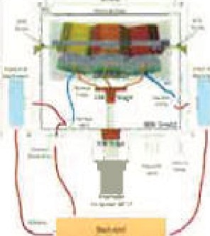
=
2·stagot GM 20K cooier
Stabillzcd (acrlw l'ID/

-- - -- -
' .. u . -
LI

ASIC Bias Board & Power iupply

o
"'

REVJSEO VERSION 31-10·2023 6/7
APPENDIX B

THE OBSERVATION SITE OF THE STRIP EXPERIMENT

A general layout of the area of the OT around the future location of the experiment STRIP is shown in the figure below. Tihe three former VSA enclosures with hexagonal shape are seen near !he centre of the image. One of the three enclosures will be the telesoope site for the STRIP experiiment. The QUIJOTE enctosure is seen southwards. Tlhe photograph also shows the site servioe building (SSB).

The IAC will prepare the final selected enclosure far the installation of the STRIP experiment The IAC should remove any debris firom the previous projects.

The IAC will provide a1suitable electrical connection point before installing the STRl'P ex¡periment.

The usability of the Wireless LAN will be exarnined in advanoe by the IAC.

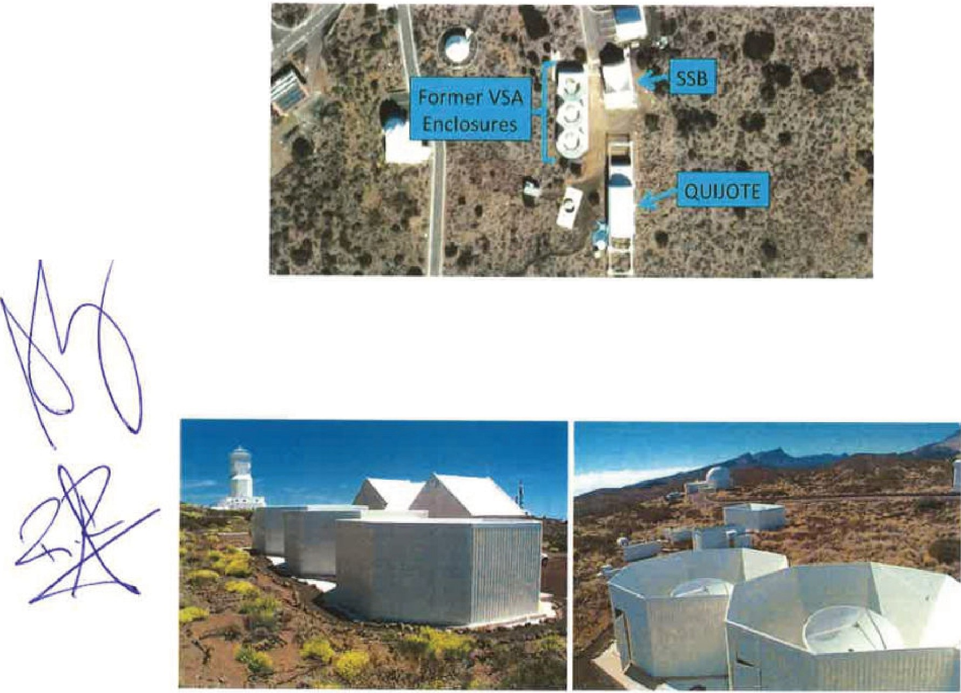
Bird's-eye view of the STRIP site (taken from Google Maps)

Former VSA enclosures

o
"' REVISED VERSION 31-10-2023 7/7

e
•O
-
"'
i
-.¡.;;
.e ,
o
e

E
]
.,
..
-o
-o
..
-o
-¡;:
""
.e.
i.,
-o.,
[L"'

